PROMISE & PRACTICE · GROWTH & CONFLICT · SOURCE ANALYSIS
The Anthem
A war going badly
Name: ______________________________ Period: _____ Date: ________________
WHAT I CAN DO TODAY I can read primary sources about The Anthem, weigh who made each one and why, and use evidence to answer historical questions.
Directions. Most Americans never learn that “The Star-Spangled Banner” has a third verse, or that it mentions slaves. Should a U.S. history class teach verse three — or is verse one enough? Make your case
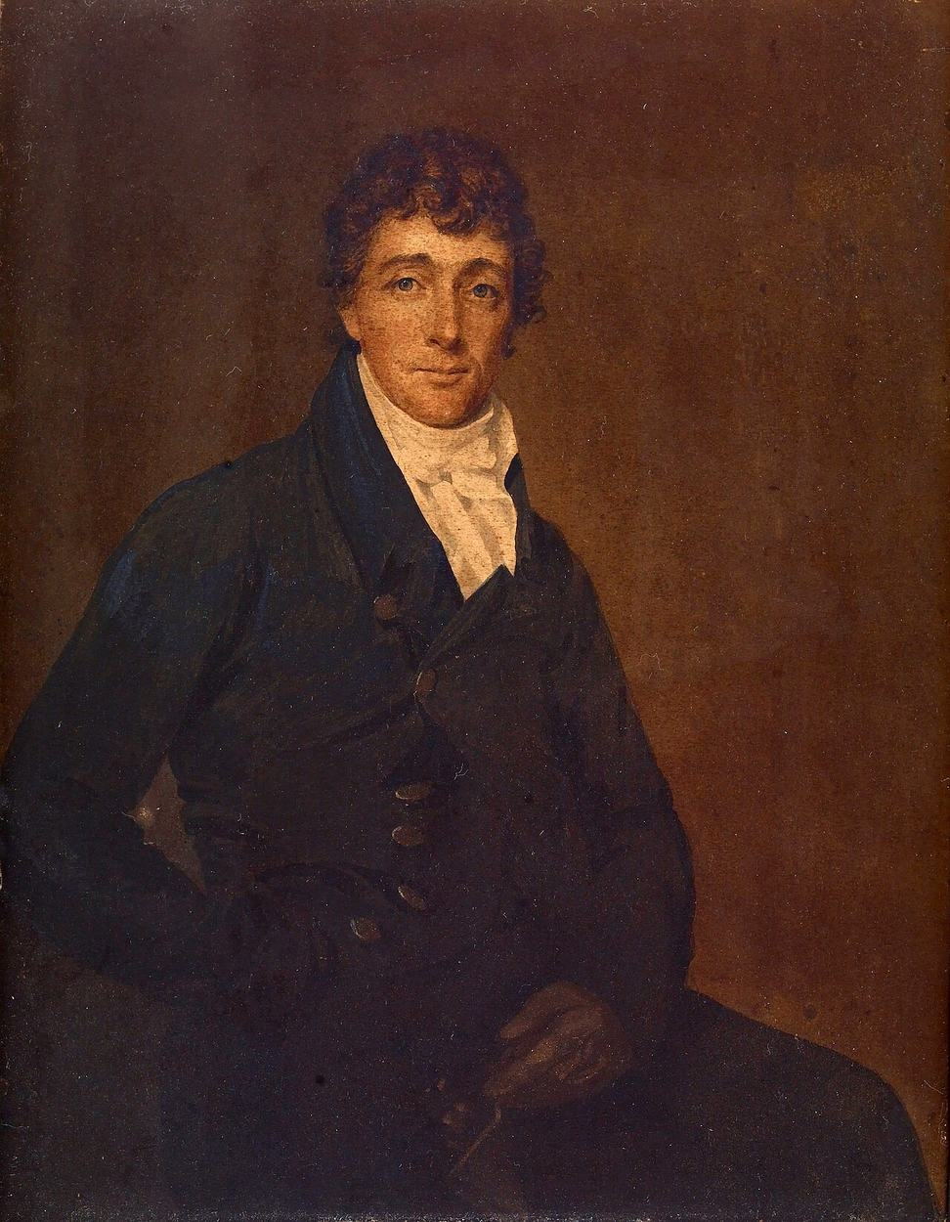
Francis Scott Key (1779–1843) — portrait, public domain.

THE SOURCES

YOUR WORK
A. WHO WROTE THE POEM, IN WHAT YEAR, AND WHAT WAS HE DOING ON A BRITISH SHIP WHEN THE BATTLE HAPPENED?
a. Who wrote the poem, in what year, and what was he doing on a British ship when the battle happened?
____________________________________________________________________________________________
____________________________________________________________________________________________
____________________________________________________________________________________________
B. SOURCING QUESTION: KEY WAS A SLAVEHOLDER WATCHING A BATTLE IN A WAR WHERE THE BRITISH WERE FREEING ENSLAVED PEOPLE. BEFORE YOU READ A SINGLE LINE, WHAT SHOULD THAT MAKE YOU READ CAREFULLY FOR?
b. Sourcing question: Key was a slaveholder watching a battle in a war where the British were freeing enslaved people. Before you read a single line, what should that make you read carefully for?
____________________________________________________________________________________________
____________________________________________________________________________________________
____________________________________________________________________________________________
A. THE VERSE ENDS WITH A QUESTION MARK. WHAT EXACTLY IS KEY ASKING — AND WHY DOESN’T HE KNOW THE ANSWER YET? POINT TO THE WORDS THAT SHOW HIS UNCERTAINTY.
a. The verse ends with a question mark. What exactly is Key asking — and why doesn’t he know the answer yet? Point to the words that show his uncertainty.
____________________________________________________________________________________________
____________________________________________________________________________________________
____________________________________________________________________________________________
____________________________________________________________________________________________
B. “BOMBS BURSTING IN AIR” SOUNDS TRIUMPHANT WHEN WE SING IT. IN ITS REAL MOMENT, WHAT DID THOSE BURSTING BOMBS ACTUALLY MEAN FOR THE PEOPLE INSIDE THE FORT?
b. “Bombs bursting in air” sounds triumphant when we sing it. In its real moment, what did those bursting bombs actually mean for the people inside the fort?
____________________________________________________________________________________________
____________________________________________________________________________________________
____________________________________________________________________________________________
A. THE MELODY WAS A BRITISH DRINKING-CLUB SONG ABOUT WINE AND LOVE. WHAT DOES IT TELL YOU ABOUT HOW NATIONAL SYMBOLS ARE MADE, THAT THE MOST PATRIOTIC AMERICAN SONG BORROWED A BRITISH BAR TUNE?
a. The melody was a British drinking-club song about wine and love. What does it tell you about how national symbols are made, that the most patriotic American song borrowed a British bar tune?
____________________________________________________________________________________________
____________________________________________________________________________________________
____________________________________________________________________________________________
B. RE-READ VERSE 3 (“NO REFUGE COULD SAVE THE HIRELING AND SLAVE…”) AND ITS CONTEXT: THE BRITISH WERE OFFERING FREEDOM TO ENSLAVED PEOPLE WHO ESCAPED. HISTORIANS DISAGREE ABOUT WHAT KEY MEANT. LAY OUT BOTH READINGS — THE ONE THAT SAYS HE’S MOCKING FREEDOM-SEEKERS, AND THE ONE THAT SAYS HE MEANS BRITISH SOLDIERS BROADLY.
b. Re-read verse 3 (“No refuge could save the hireling and slave…”) and its context: the British were offering freedom to enslaved people who escaped. Historians disagree about what Key meant. Lay out BOTH readings — the one that says he’s mocking freedom-seekers, and the one that says he means British soldiers broadly.
____________________________________________________________________________________________
____________________________________________________________________________________________
____________________________________________________________________________________________
____________________________________________________________________________________________
CLAIM — YOUR POSITION IN ONE CLEAR SENTENCE.
CLAIM — your position in one clear sentence.
____________________________________________________________________________________________
____________________________________________________________________________________________
____________________________________________________________________________________________
EVIDENCE — AT LEAST TWO SPECIFIC THINGS FROM THIS PRESENTATION THAT SUPPORT YOUR CLAIM.
EVIDENCE — at least two specific things from this presentation that support your claim.
____________________________________________________________________________________________
____________________________________________________________________________________________
____________________________________________________________________________________________
____________________________________________________________________________________________
REASONING — WHY DOES THAT EVIDENCE SUPPORT YOUR CLAIM? WHAT IS GAINED, AND WHAT IS RISKED, EITHER WAY?
REASONING — why does that evidence support your claim? What is gained, and what is risked, either way?
____________________________________________________________________________________________
____________________________________________________________________________________________
____________________________________________________________________________________________
____________________________________________________________________________________________
Promise & Practice · ShadowDog Digital Studios · Unit 2

TEACHER ANSWER KEY — The Anthem

a. Who wrote the poem, in what year, and what was he doing on a British ship when the battle happened?: Open response.
b. Sourcing question: Key was a slaveholder watching a battle in a war where the British were freeing enslaved people. Before you read a single line, what should that make you read carefully for?: Open response.
a. The verse ends with a question mark. What exactly is Key asking — and why doesn’t he know the answer yet? Point to the words that show his uncertainty.: Open response.
b. “Bombs bursting in air” sounds triumphant when we sing it. In its real moment, what did those bursting bombs actually mean for the people inside the fort?: Open response.
a. The melody was a British drinking-club song about wine and love. What does it tell you about how national symbols are made, that the most patriotic American song borrowed a British bar tune?: Open response.
b. Re-read verse 3 (“No refuge could save the hireling and slave…”) and its context: the British were offering freedom to enslaved people who escaped. Historians disagree about what Key meant. Lay out BOTH readings — the one that says he’s mocking freedom-seekers, and the one that says he means British soldiers broadly.: Open response.
CLAIM — your position in one clear sentence.: Open response.
Look for a response along the lines of: “Schools should / should not …”
EVIDENCE — at least two specific things from this presentation that support your claim.: Open response.
REASONING — why does that evidence support your claim? What is gained, and what is risked, either way?: Open response.

